Remarques de dvr springboot
One to Many
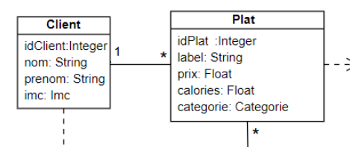
Entite client
**
@OneToMany(cascade = CascadeType.ALL, mappedBy="client")
private Set<Plat> Plats;
Pour enumeration
public enum Imc{
FAIBLE,IDEAL,FORT
}
MANY TO MANY
@ManyToMany(cascade = CascadeType.ALL)
private Set<Cuisinier> cuisiniers;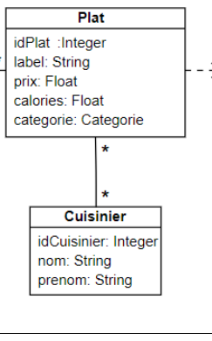
public enum Categorie{
ENTREE,PRINCIPAL,DESSERT
}
MANY TO ONE
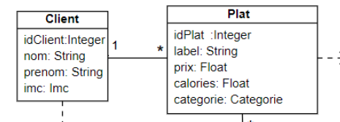

Pour le Plat
@ManyToOne
Client client;
@ManyToMany(cascade = CascadeType.ALL)
private Set<Cuisinier> cuisiniers;
public enum Categorie{
ENTREE,PRINCIPAL,DESSERT
}
}
Ses pour les entities

